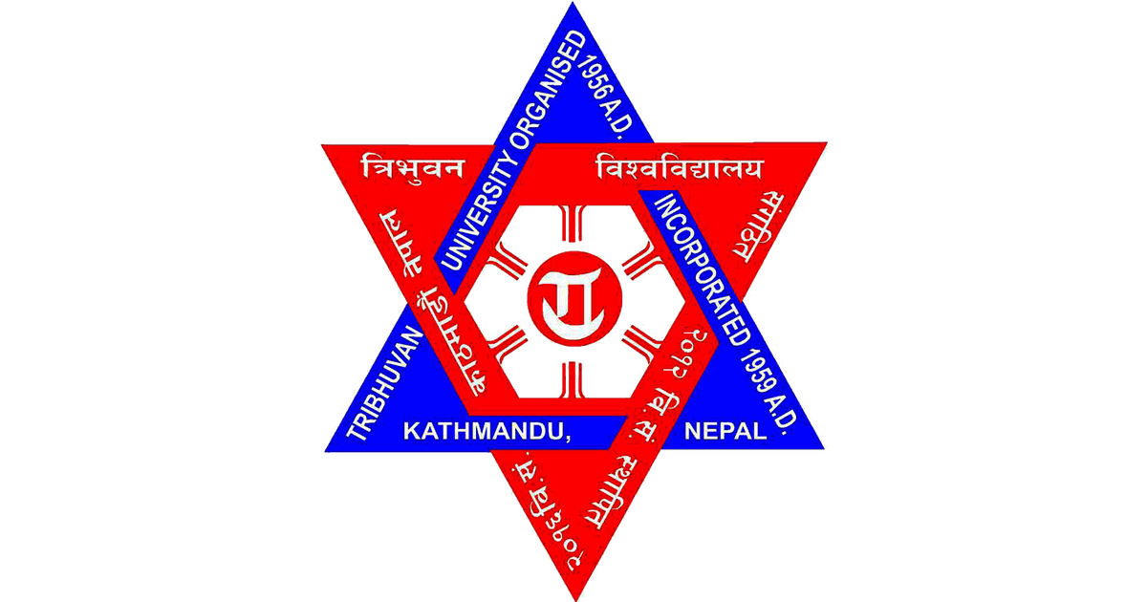
Tribhuvan University
Faculty of Humanities and Social Science
Saraswati Multiple Campus
Lekhnath marga, Kathmandu

Society And Technology Report
Submitted By: Submitted To:
Name: Bikram Gyawali Name: Mrs.Radhika Dahal
Roll No: 22
Level: BCA (1st Semester) ………………………………
Subject: Society and Technology Signature
Subject Code: CACS 102

